DINESHKUMAR S  D. Pharmacy Graduate | Pharmacist  📞 +91 70102 22389  ✉ dineshkumarprema09@gmail.com  📍 Alangayam, Vellore District, Tamil Nadu | 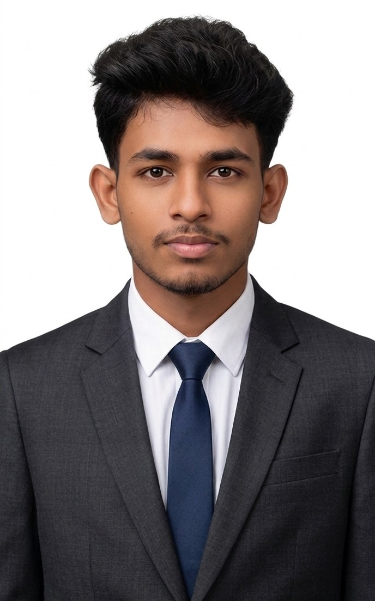

CAREER OBJECTIVE
A dedicated and hardworking D. Pharmacy graduate with hands-on experience as a Pharmacist, seeking an opportunity to contribute effectively in a professional pharmacy or healthcare setting. Committed to delivering quality patient care and pharmaceutical services with sincerity and a professional attitude.
EDUCATION
Diploma in Pharmacy (D. Pharm)
GP Pharmacy College | Vaniyambadi, Tirupattur, Tamil Nadu | 2023 – 2025
Higher Secondary Certificate (HSC) – Class XII
Govt Boys HR Sec School, Alangayam | Tamil Nadu State Board | March 2023
Class XI: 296/600 | Class XII: 344/600 | Subjects: Tamil, English, Physics, Chemistry, Biology, Mathematics
Secondary School Leaving Certificate (SSLC) – Class X
Govt Boys HR Sec School, Alangayam | Tamil Nadu State Board | March 2021
WORK EXPERIENCE
Pharmacist | Saravana Medical, Tamil Nadu
November 2024 – December 2025
- Dispensed medications accurately and provided patient counselling on drug usage and dosage.
- Managed drug inventory, stocking of medicines and medical devices.
- Handled prescriptions and maintained proper records in compliance with pharmacy regulations.
- Recognized as a sincere, honest, and hardworking employee with a professional attitude and good job knowledge.
Student Pharmacist (Practical Training) | Govt Hospital, Vaniyambadi
January 2026 – March 2026 (3 Months)
- Completed practical training under the Pharmacy Act, 1948 and Education Regulations, 2020.
- Gained experience in stocking drugs, inventory control, handling prescriptions, dispensing, and patient counselling.
- Trained under a registered Pharmacist (Apprentice Master: P. Venkatesan, D. Pharm).
SKILLS
- Drug dispensing & prescription handling  - Patient counselling  - Inventory & stock management  - Knowledge of Pharmacy Acts & Regulations | - Record keeping & documentation  - Handling of medical devices  - Teamwork & communication  - Hardworking & detail-oriented
ACHIEVEMENTS & CERTIFICATIONS
- 2nd Place – Poster Presentation at World Pharmacist Day Celebration 2024, GP Pharmacy College, Mandalavadi, Tirupattur.
- Paper Presented – International Seminar on 'Millets in World Literature' organised by Yelagiri Bharathi Tamil Sangam, held at GP Pharmacy College & Palar Agriculture College, September 2023.
- Completed Government of Tamil Nadu Practical Training Contract (Pharmacy Act) – 3 months, Govt Hospital, Vaniyambadi (2026).
- Participated – Hindi Hand Writing Competition, St. Francis De Sales Mat. Hr. Sec. School, Vellore (2013).
- 2nd Place – 50m Running, Annual Sports Meet 2016–17, Panchayat Union Middle School, Kallarapatti, Alangayam Block, Vellore District.
- Certificate of Merit – Eloquence Event, Annual Sports Meet 2016–17, Panchayat Union Middle School, Kallarapatti, Alangayam.
PERSONAL DETAILS
Date of Birth: 09 September 2005
Father's Name: Saravanan
Mother's Name: Prema
Languages Known: Tamil, English, Hindi
Medium of Instruction: Tamil
Location: Alangayam, Vellore District, Tamil Nadu – 635 701
DECLARATION
I hereby declare that all the information provided above is true and correct to the best of my knowledge and belief.
Place: Alangayam
Date: 12 / 04 / 2026
(DINESHKUMAR S)

